**Project Name:** Password Generator System

**Github Link:** https://github.com/projectsforstudents2022/Password_Generator_System.git

**Why was this project created?**

A highly popular user authentication method is the text password. Users have a serious issue with the number of secure passwords that are site-specific. Using a password generator that produces site-specific strong passwords on demand with little user input is one technique to deal with this.

**What problem is it solving?**

Our goal in this project is to create a random password based on the requirements of the user. The user will enter the number of digits, special characters, tiny alphabets, and capital alphabets that they require, and a random password will be generated using these numbers. After creating a random password, clicking the "Copy to Clipboard" button will allow us to copy the password to our clipboard.

**Entire explanation of project**

* **PROPOSED APPROACH**

Despite widespread worries about the level of security they provide, passwords are nevertheless a fairly popular means of user authentication. It is possible that passwords will eventually be replaced by a variety of technologies, such as biometric and trusted personal devices used in tandem. However, it is likely that this will take some time. Finding ways to improve the use and administration of passwords remains a critically essential topic given their widespread usage both now and in the future. Here, we concentrate on a crucially practical issue, specifically how to make passwords more convenient and secure. Passwords can be kept locally or on a reliable server; most browsers come with a password manager for local storage. The drawbacks of password managers, however, have also been well-documented.

With the use of a password generator, a user can create a password with any combination of letters, numbers, or words of their choosing. The password generated by the Password Generator can be copied using the Clipboard. The user can also use it to assess the security of the passwords. Additionally, it shows the quantity of letters, numbers, and symbols used in the passwords.

* **DATA FLOW DIAGRAM**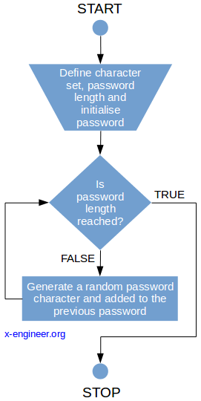
* **RESULT**

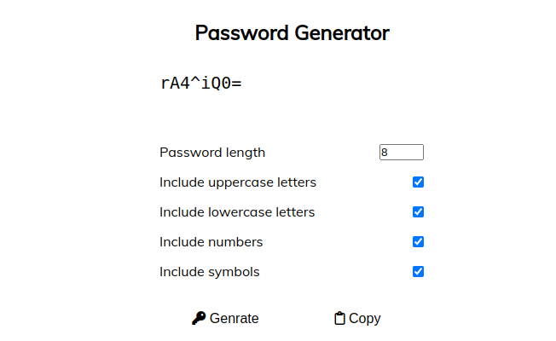

* **CONCLUSION**

We were able to develop a software that generates random passwords. In addition to learning about the pyperclip and random libraries, we used the well-known tkinter library to generate graphics in our display window. Button, input text box, and label creation skills were acquired. This was how we successfully finished the Python project for our password generator.